Sitio web para la administración de la Intranet de la Empresa Eléctrica Quito
Tema de apariencia en Eclipse
  - Templates
Archivo init_custom.vm

Archivo portal_normal.vm
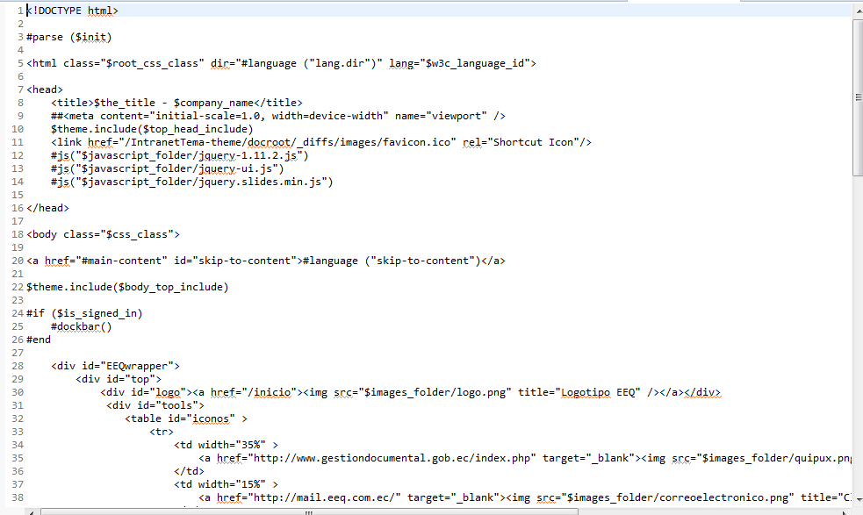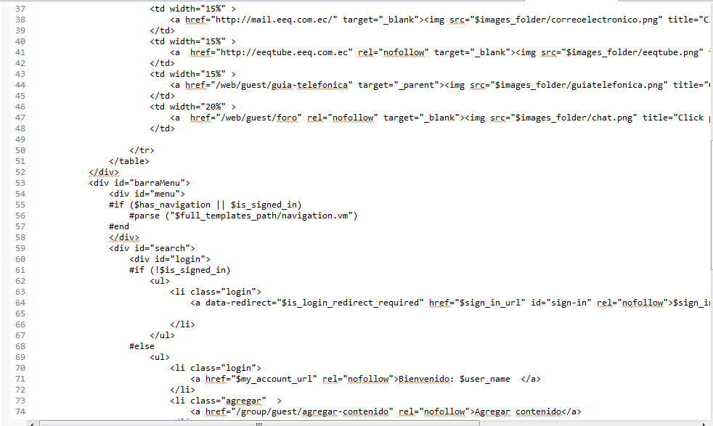
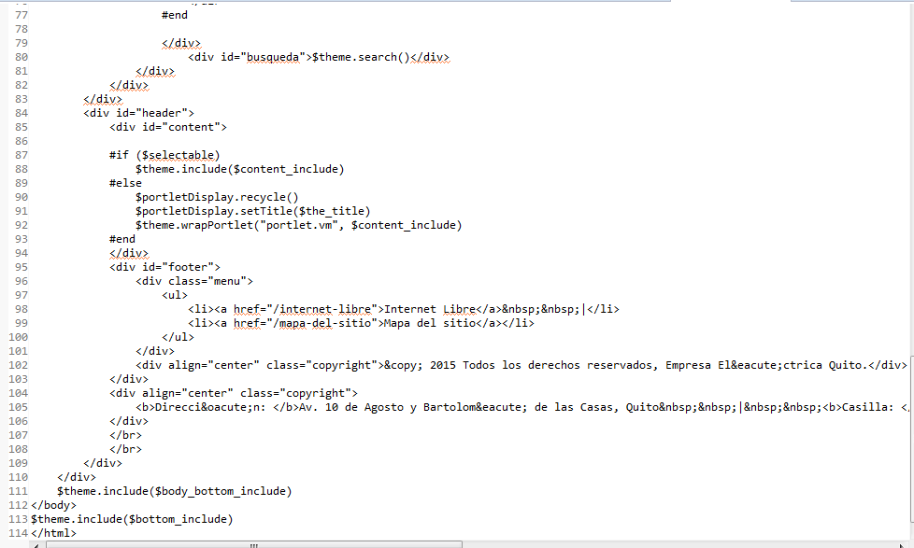
Archivo navigation.vm
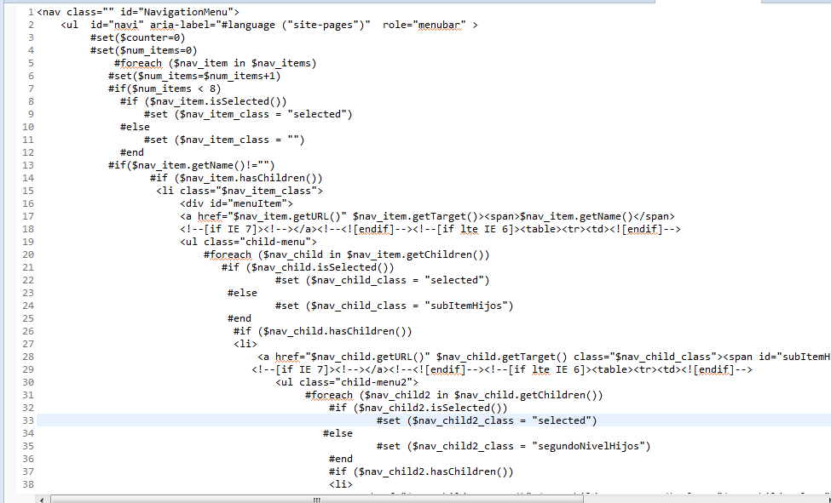
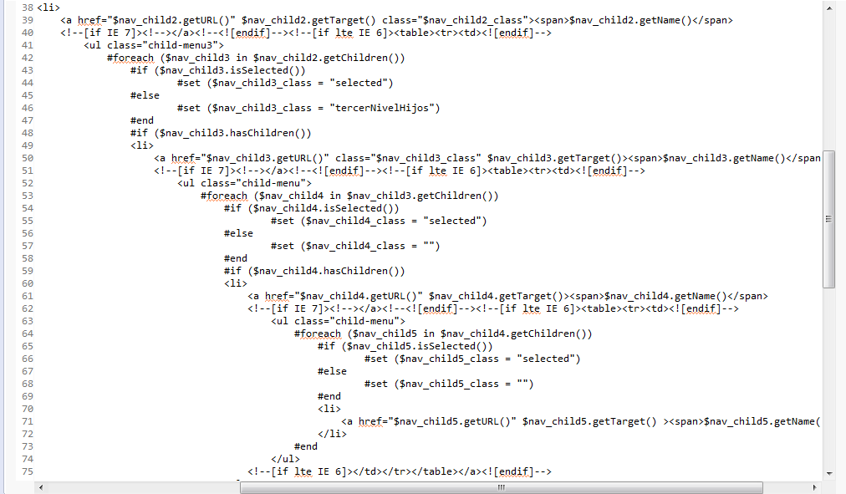
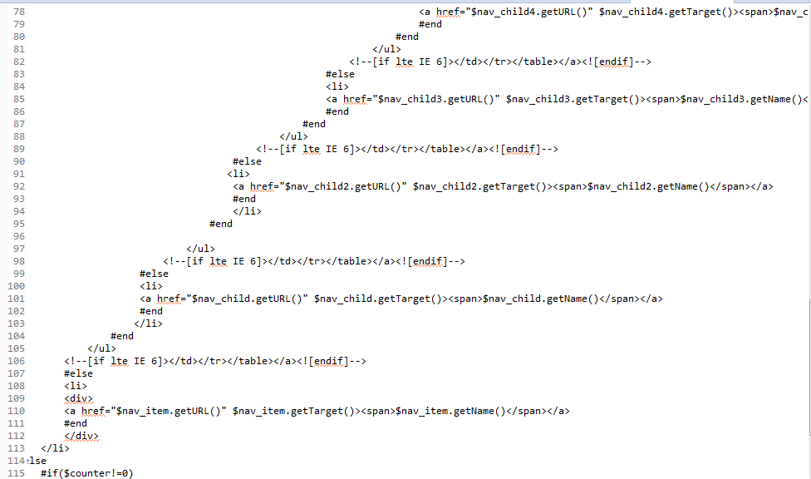

  - Hojas de estilo
Archivo custom.css

@charset "UTF-8";
/* CSS Document */

#NavigationMenu, #NavigationMenu * {
/* z-index:992;*/
}

#NavigationMenu {
position:absolute;
height: 40px;

}

#NavigationMenu ul,
#add-page {
float: left;
width:auto;
}

#NavigationMenu a {
display: block;
text-decoration: none;
height: 40px;
margin: 0 0px 0 0;
padding: 3px 10px 4px;
line-height:30px;
}

#NavigationMenu .selected a {
background: #0077af;
color: #fff;
font-weight: normal;
}

#NavigationMenu .cancel-page {
display: none;
}

#NavigationMenu .save-page {
display: inline;
}

#NavigationMenu li {
position:relative;
height:auto;
}
/*****************/
/* hide the sub levels and give them a positon absolute so that they take up no room */
#NavigationMenu ul ul {
visibility:hidden;
position:absolute;
}

/* style the table so that it takes no part in the layout - required for IE to work */
#NavigationMenu table {position:absolute; }

/* style the second level links */
#NavigationMenu ul ul a, #NavigationMenu ul ul a:visited {
font-weight:normal;
background:#0077af;
height:auto;
line-height:1em;
/*padding:5px 10px;*/
/*width:12em;*/
text-align:left;
border-bottom: 1px dotted #0099CC;
}

/* style the top level hover */
#NavigationMenu a:hover{
background:none;
color:#000;
}
#NavigationMenu .drop1 a:hover,#NavigationMenu ul ul a:hover{
color:#fff;
background:#0077af;
}
#NavigationMenu .drop1 :hover > a, #NavigationMenu ul ul :hover > a {
color:#fff;
background:#0077af;
}

/* make the second level visible when hover on first level list OR link */
#NavigationMenu ul li:hover ul{
visibility:visible;
top:auto;
}
#NavigationMenu ul a:hover ul{
visibility:visible;
top:20px;
}
/* keep the third level hidden when you hover on first level list OR link */
#NavigationMenu ul :hover ul ul{
visibility:hidden;
}
/* keep the fourth level hidden when you hover on second level list OR link */
#NavigationMenu ul :hover ul :hover ul ul{
visibility:hidden;
}
/* make the third level visible when you hover over second level list OR link */
#NavigationMenu ul :hover ul :hover ul{
visibility:visible;

}
/* make the fourth level visible when you hover over third level list OR link */
#NavigationMenu ul :hover ul :hover ul :hover ul {
visibility:visible;
}
#NavigationMenu li a span{
font: 14px Arial, Helvetica, sans-serif;

line-height:18px;

text-shadow: 1px 1px 1px #333333, 3px 3px 5px #666666;
}
/*drop down ends*/

/* ---------- drop down menu ---------- */
#navi, #navi ul{
margin:0;
padding:0;
list-style-type:none;
list-style-position:outside;
/* position:relative;*/
line-height:1.5em;
z-index:992;
}

#navi a:link{
display:block;
margin:0px;
padding-top:5px;

}

#navi a:active, #navi a:visited{
display:block;
color:#fff;
text-decoration:none;
}

#navi a:hover{
background-color:#0077af;
color:#fff;
}

#navi li{
float:left;
position:relative;
}

#navi ul {
position:relative;
/* to make the menu above iframes */
/* z-index:110;*/
height:3em;
top:1.5em;
display:none;
width:100%;
}

#navi li ul a{
height:2em;
float:left;
}

#navi ul ul{
top:auto;
}

#navi li ul ul {
left:11.8em;
margin:0px 0 0 10px;
}

#navi li:hover ul ul, #navi li:hover ul ul ul, #navi li:hover ul ul ul ul{
display:none;
left:20.05em;
}
#navi li:hover ul, #navi li li:hover ul, #navi li li li:hover ul, #navi li li li li:hover ul{
display:block;
}

#navigationMenu ul:after {
clear: both;
content: ".";
display: block;
height: 0;
visibility: hidden;
}

.ie #navigationMenu ul {
height: 1%;
}

.ie6 #navigationMenu, .ie6 #navigationMenu ul {
height: 2em;
overflow: visible;

}
.child-menu li a{
display: none;
width:13em;
float:right;

}
#menuItem .child-menu li a.subItemHijos{

background: #0077af url(../images/bullet_submenu.png) no-repeat;
background-position:230px;

}
#menuItem .child-menu .child-menu2 li a.segundoNivelHijos{

background: #0077af url(../images/menu/bullet_submenu.png) no-repeat;
background-position: 230px;

}
#menuItem .child-menu .child-menu2 .child-menu3 li a.tercerNivelHijos{
background: #0077af url(../images/menu/bullet_submenu.png) no-repeat;
background-position: 230px;

}
#menuItem .child-menu .child-menu2 a{
height: 40px;
}

#menuItem{
background: url(../images/menu/menu_bullet.png) no-repeat right 20px;
}

Archivo estilos.css
@charset "utf-8";

/*aumentado*/

/*----------------------------------------*/
/* CSS Document */
/*dockbar*/
.aui .dockbar-split .dockbar .navbar-inner .nav-add-controls > li {
border-radius: 6px;
}
.aui .dockbar-split .dockbar.navbar-static-top .collapse .nav-account-controls li a{line-height:20px;}
.dockbar-user-notifications .dropdown-toggle .user-notifications-count {line-height: 1.1em;margin: 1px 0px;}
.aui .dockbar-split .dockbar .navbar-inner .nav-add-controls > li > a {
background: none repeat scroll 0% 0% #45CBF5;
background-color: #45CBF5;
background-image: none;
background-repeat: repeat;
background-attachment: scroll;
background-position: 0% 0%;
background-clip: border-box;
background-origin: padding-box;
background-size: auto auto;
border-radius: 4px;
}
.aui .dockbar-split .dockbar .navbar-inner .nav-add-controls > li > a:hover {

background-color: rgba(255, 255, 255, 0.2);
background-image: none;
background-repeat: repeat;
background-attachment: scroll;
background-position: 0% 0%;
background-clip: border-box;
background-origin: padding-box;
background-size: auto auto;
border-radius: 4px;
}

.dockbar div.nav-collapse .dropdown-menu > li > a {color:#fff;}
.aui .dropdown-menu{margin:0px;}

.aui .dockbar-split .dockbar .navbar-inner .nav > li {
background-image:-webkit-linear-gradient(top, #118ADE, #1273C7);
background-image: -moz-linear-gradient(center top ,#118ADE, #1273C7 );
background-image: linear-gradient(top ,#118ADE, #1273C7 );
color:#ffffff;
background-color: #118ADE;

}

.user-avatar-image {
border-radius: 50px;
}
.aui .navbar .icon-caret-down{
border-radius: 50px;
-webkit-border-radius: 50%;
background: none repeat scroll 0% 0% rgba(255, 255, 255, 0.2);
background-color: rgba(255, 255, 255, 0.2);
background-image: none;
background-repeat: repeat;
background-attachment: scroll;
background-position: 0% 0%;
background-clip: border-box;
background-origin: padding-box;
background-size: auto auto;
font-size: 14px;
height: auto;
margin-left: 5px;
padding: 1px 4px;
width: auto;

}

.aui .dockbar .navbar-inner {
background-image: -webkit-linear-gradient(top , #118ADE, #1273C7);
background-image: -moz-linear-gradient(center top , #118ADE, #1273C7);
background-image: linear-gradient(top , #118ADE, #1273C7);
background-color: #118ADE;

}
.aui .dockbar .navbar-inner ul.nav-account-controls li.open > .dropdown-toggle {
background-color: #118ADE;
background-image: -moz-linear-gradient(center top , #0EA6F9, #0993DD );
background-image:-webkit-linear-gradient( top ,#0EA6F9, #0993DD );
background-image: linear-gradient( top ,#0EA6F9, #0993DD );
box-shadow: none;
}
.aui .dockbar .navbar-inner .site-administration-menu li a{
color:#ffffff;
}
.aui .dockbar .nav li.dropdown .dropdown-menu, .aui .dockbar .nav li.dropdown .site-administration-menu {
background: none repeat scroll 0% 0% #009AE5;
background-color: #009AE5;
background-image: none;
background-repeat: repeat;
background-attachment: scroll;
background-position: 0% 0%;
background-clip: border-box;
background-origin: padding-box;
background-size: auto auto;
color:#ffffff;
border-radius:0px;
border:0px;
}
.aui .dockbar-split .dockbar .navbar-inner .nav-add-controls > li > a {
background: none repeat scroll 0% 0% #45CBF5;
background-color: #45CBF5;
background-image: none;
background-repeat: repeat;
background-attachment: scroll;
background-position: 0% 0%;
background-clip: border-box;
background-origin: padding-box;
background-size: auto auto;
color:#ffffff;
}
/* cuerpo */
a.portlet-icon-back:hover{
color:#0000ff;
}
.aui body,td,th,a {
font-family: Arial, Helvetica, sans-serif;
font-size: 12px;
color:#666;
text-decoration:none;
}

body {
background-image: url(../images/bg.jpg);
background-repeat: repeat;
margin:0 0;
}

.aui a{
color:#666;
text-decoration:none;

}
p{ line-height:18px; }

a.boton{ background:#999; padding:5px;color:#fff; font-weight:bold;margin:10px;}
a.boton:hover{ background:#0077AF; padding:5px;}

.aui h1, h2, h3 {
font-size: 12px;
color:#666;
margin:0 0 10px 0;
}

.aui h4{font-size:10px;}

.aui form {
margin:0 0 -7px;
}

div.content img{ margin: 0 8px; border: 3px solid #CCC;}

/*wrapper*/
#EEQwrapper{
margin:0 auto;
width:1060px;
background:#f6f6f5;

}

/*barra de menu*/
#barraMenu{float:right; width:1060px; margin-top:2px;}
#menu{ background:url(../images/menubg.png) repeat-x; height:45px;}
#menu ul{list-style:none; margin:0;}
#menu ul li{float:left; line-height:43px;}
#menu ul li.active, #menu ul li:hover{ background:#0077AF;}
#menu ul li a{color:#fff; margin-top:5px; padding:0 21px; font-size:16px; text-decoration:none;}
#NavigationMenu ul ul a:hover{background: #3196d4;}
#menuItem .child-menu .child-menu2 li a:hover {
background: #3196d4;
background-position: 230px;
}
#menuItem .child-menu li a.subItemHijos:hover{
background: #3196d4 url(../images/bullet_submenu.png) no-repeat;
background-position:230px;
}

/*header, logo, slogan, barra debajo del menu*/

#busqueda select{
display:none;
}
#busqueda{float:right; margin:5px 20px 5px 0;}

#tablaSlogan{
}
#logos{
width:1060px;
}
#iconos{
width:380px;
margin-top:20px;
border-spacing:21px 0px;
}

#iconos td{
vertical-align:bottom;
text-align:center;
}

#logo{float:left; margin:12px 0px 0px 20px; }
#tools{float:right;padding:0px 80px;}
#search{margin:0; background:#FFF;float:left; width:1060px;}

/*boton para inicio de sesion*/
#login{float:left;margin:6px;}
#login ul{list-style:none; margin:0;}
#login ul li{height:25px; float:left; margin:0 8px; padding:0 10px 0 25px;}
#login ul li.login{background: url(../images/list_key.png) 3px center no-repeat #ddd; }
#login ul li.agregar{background:url(../images/common/add_article.png)3px center no-repeat #ddd;}
#login ul li a{ text-align:center; text-decoration:none; color:#333; display:block; margin-top:5px;}

input,select option{height:20px;}
input#button{ background:#009EE2; color:#FFF; padding:5px; height:auto;
-webkit-box-shadow: 0px 0px 3px rgba(50, 50, 50, 0.75);
-moz-box-shadow: 0px 0px 3px rgba(50, 50, 50, 0.75);
box-shadow: 0px 0px 3px rgba(50, 50, 50, 0.75);}

/*slider*/
#back_to_camera {
clear: both;
display: block;
height: 80px;
line-height: 40px;
padding: 20px;
margin-bottom:10px;
}
.fluid_container {
margin: 0 auto;
/*max-width: 1000px;*/
width: 980px;

}

.fluid_container_banner{
margin: 0 auto;
/*max-width: 1000px;*/
width: 305px;
display:inline-block;
}

#header{clear:both; margin:0px 15px ; display:block;}

/*modulos de la pagina de inicio*/

.menu {
position:relative;
width:auto;
}
/*modulo 1 */
div.module1{background:#fff; margin:0 0 10px 0;-webkit-border-radius: 8px;
-moz-border-radius: 8px;
border-radius: 8px; padding-bottom:10px; color:#666;}
div.module1 h2{
-webkit-border-top-left-radius: 8px;
-webkit-border-top-right-radius: 8px;
-moz-border-radius-topleft: 8px;
-moz-border-radius-topright: 8px;
border-top-left-radius: 8px;
border-top-right-radius: 8px;
background:url(../images/modulebg1.png);
height:20px;

padding:4px 10px 19px 50px;
font-size: 16px;
font-weight: normal;

color:#fff;
}
div.module1 ul{
list-style:none;
margin:0;
padding:0px;
}
div.module1 ul li{
color:#333;
padding: 5px 4px;
border-bottom:1px #CCCCCC dotted;
margin:0 15px;
list-style-image:url(../images/list.png);
list-style-position:inside;
}
div.module1 ul li a{color:#333;}

/*modulo 2 */
div.module2{background:#fff; margin:0 0 10px 0;-webkit-border-radius: 8px;
-moz-border-radius: 8px;
border-radius: 8px; padding-bottom:10px; color:#666;}
div.module2 h2{
-webkit-border-top-left-radius: 8px;
-webkit-border-top-right-radius: 8px;
-moz-border-radius-topleft: 8px;
-moz-border-radius-topright: 8px;
border-top-left-radius: 8px;
border-top-right-radius: 8px;
background:url(../images/modulebg2.png);
height:20px;

padding:4px 10px 19px 50px;
font-size: 16px;
font-weight: normal;

color:#fff;
}
div.module2 ul{
list-style:none;
margin:0;
padding:0px;
}
div.module2 ul li{
color:#333;
padding: 5px 4px;
border-bottom:1px #CCCCCC dotted;
margin:0 15px;
list-style-image:url(../images/list3.png);
list-style-position:inside;
}
div.module2 ul li a{color:#333;}
div.module2 .content{ padding:0 10px;}

/*modulo 3 */
div.module3{background:#fff; margin:0 0px 10px 0;-webkit-border-radius: 8px;
-moz-border-radius: 8px;
border-radius: 8px; padding-bottom:10px; color:#666;}
div.module3 h2{
-webkit-border-top-left-radius: 8px;
-webkit-border-top-right-radius: 8px;
-moz-border-radius-topleft: 8px;
-moz-border-radius-topright: 8px;
border-top-left-radius: 8px;
border-top-right-radius: 8px;
background:url(../images/modulebg3.png);
height:20px;

padding:4px 10px 19px 50px;
font-size: 16px;
font-weight: normal;
color:#fff;
}
div.module3 ul{
list-style:none;
margin:0;
padding:0px;
}
div.module3 ul li{
color:#333;
padding: 5px 4px;
border-bottom:1px #CCCCCC dotted;
margin:0 15px;
list-style-image:url(../images/list.png);
list-style-position:inside;
}
div.module3 ul li a{color:#333;}

div.module3 .content{ padding:0 10px;}

/*modulo 4 */
div.module4{background:#fff; margin:0 0px 10px 0;-webkit-border-radius: 8px;
-moz-border-radius: 8px;
border-radius: 8px; padding-bottom:10px; color:#666;}
div.module4 h2{
-webkit-border-top-left-radius: 8px;
-webkit-border-top-right-radius: 8px;
-moz-border-radius-topleft: 8px;
-moz-border-radius-topright: 8px;
border-top-left-radius: 8px;
border-top-right-radius: 8px;
background:url(../images/modulebg4.png);
height:20px;

padding:4px 10px 19px 50px;
font-size: 16px;
font-weight: normal;

color:#fff;
}
div.module4 ul{
list-style:none;
margin:0;
padding:0px;
}
div.module4 ul li{
color:#333;
padding: 5px 4px;
border-bottom:1px #CCCCCC dotted;
margin:0 15px;
list-style-image:url(../images/list.png);
list-style-position:inside;
}
div.module4 ul li a{color:#333;}

/*modulo 5 */
div.module5{
background:url(../images/comite.png) no-repeat;
margin:0 0px 10px 0;
-webkit-border-radius: 8px;
-moz-border-radius: 8px;
border-radius: 8px;
padding-bottom:10px;
}

/*margin:0 0px 10px 0;
-webkit-border-radius: 8px;
-moz-border-radius: 8px;
border-radius: 8px;
padding-bottom:10px;
color:#666;
height:175px;
width:314;
background:url(../images/comite.png) no-repeat;
}*/

div.module5 a{
height:200px;
width:345px;
display:block;
overflow:hidden;
text-indent:100%;
white-space:nowrap;

}

/*modulo 6 */
div.module6{background:#fff; margin:0 0px 10px 0;-webkit-border-radius: 8px;
-moz-border-radius: 8px;
border-radius: 8px; padding-bottom:10px; color:#666;}
div.module6 h2{
-webkit-border-top-left-radius: 8px;
-webkit-border-top-right-radius: 8px;
-moz-border-radius-topleft: 8px;
-moz-border-radius-topright: 8px;
border-top-left-radius: 8px;
border-top-right-radius: 8px;
background:url(../images/modulebg6.png);
height:20px;
white-space:nowrap;

padding:4px 10px 19px 63px;
font-size: 16px;
font-weight: normal;

color:#fff;
}
div.module6 ul{
list-style:none;
margin:0;
padding:0px;
}
div.module6 ul li{
color:#333;
padding: 5px 4px;
border-bottom:1px #CCCCCC dotted;
margin:0 15px;
list-style-image:url(../images/list.png);
list-style-position:inside;
}
div.module6 ul li a{color:#333;}

div.module6 .content{ padding:0 10px;}

/*modulo 7 */
div.module7{
padding:0px 30px 10px 30px;
margin-bottom:10px;
background:#fff;
}

div.module7 ul{
list-style:none;
margin:0;
padding:0px;
}
div.module7 ul li{
padding: 5px 4px;
border-bottom:1px #CCCCCC dotted;
margin:0 15px;
list-style-image:url(../images/list.png);
list-style-position:inside;
}
div.module7 ul li a:hover{color: #CC9600;
text-decoration:none;}

/*modulo 8 */
div.module8{background:#fff; margin:0 0 10px 0;-webkit-border-radius: 8px;
-moz-border-radius: 8px;
border-radius: 8px; padding-bottom:10px; color:#666;}
div.module8 h2{
-webkit-border-top-left-radius: 8px;
-webkit-border-top-right-radius: 8px;
-moz-border-radius-topleft: 8px;
-moz-border-radius-topright: 8px;
border-top-left-radius: 8px;
border-top-right-radius: 8px;
background:url(../images/modulebg7.png);
height:20px;

padding:4px 10px 19px 50px;
font-size: 16px;
font-weight: normal;

color:#fff;
}
div.module8 ul{
list-style:none;
margin:0;
padding:0px;
}
div.module8 ul li{
color:#333;
padding: 5px 4px;
border-bottom:1px #CCCCCC dotted;
margin:0 15px;
list-style-image:url(../images/list3.png);
list-style-position:inside;
}
div.module8 ul li a{color:#333;}
div.module8 .content{ padding:0 10px;}

/*modulo 9 */
div.module9{background:#fff; margin:0 0 10px 0;-webkit-border-radius: 8px;
-moz-border-radius: 8px;
border-radius: 8px; padding-bottom:10px; color:#666;}
div.module9 h2{
-webkit-border-top-left-radius: 8px;
-webkit-border-top-right-radius: 8px;
-moz-border-radius-topleft: 8px;
-moz-border-radius-topright: 8px;
border-top-left-radius: 8px;
border-top-right-radius: 8px;
background:url(../images/modulebg8.png);
height:20px;

padding:4px 10px 19px 50px;
font-size: 16px;
font-weight: normal;

color:#fff;
}
div.module9 ul{
list-style:none;
margin:0;
padding:0px;
}
div.module9 ul li{
color:#333;
padding: 5px 4px;
border-bottom:1px #CCCCCC dotted;
margin:0 15px;
list-style-image:url(../images/list3.png);
list-style-position:inside;
}
div.module9 ul li a{color:#333;}
div.module9 .content{ padding:0 10px;}
/*pie de sitio */

#footer{ border-top: 1px solid #999; padding: 10px 0; width:100%; display: inline-block; margin-top:15px; }
#footer .menu ul{ list-style:none; margin:0; padding:0; float:left;}
#footer .menu ul li{ float:left; padding:0 10px 0 0;}
#footer .copyright{float:right;}

/*contenedor*/
.content{padding:15px;}

.content{
background:#fff;
padding:15px;
}

.portlet-topper .portlet-topper-toolbar .portlet-icon-back {
color:#666;
background:url("../images/arrows/11_left.png") 0px 50% no-repeat;
}

.portlet-borderless-bar a {
background:url(../images/portlet/options_borderless.png) 0px 50% no-repeat;
}
/*portlet de navegacion*/
/* Header */
.nav-menu h2{ border-bottom: 0px solid #ddd;
background: url("../images/modulebg1.png") no-repeat 0% 0%; border-top-left-radius: 8px;
border-top-right-radius: 8px;
height: 40px;
line-height: 33px;
padding: 0px 18px 0px 50px;
margin: 0px;
}
.nav-menu h2 a, .nav-menu h2:hover a{
text-decoration: none; color: #FFF;
font-weight: normal;
font-size: 16px;
text-shadow: none;

}
/* Layout for level 1 */
.nav-menu .layouts.level-1{
background: #fff;
padding: 5px 18px 5px 18px;
border-bottom: 0px solid #e5e5e5;
margin-bottom: 8px;
border-bottom-right-radius:
8px; border-bottom-left-radius:
8px; margin: 0px;
}
.nav-menu ul.layouts{
margin: 0px;
padding: 0px;
}
.nav-menu ul.layouts .level-1 li, .nav-menu ul.layouts .level-2 li{
padding-left: 7px;
margin: 5px;
}
.nav-menu ul.layouts .level-3 li, .nav-menu ul.layouts .level-4 li, .nav-menu ul.layouts .level-5 li{
padding-left: 7px;
margin: 5px; margin-right: 0px;
}
/* List elements */
.nav-menu ul li{
list-style-type: none;
color: #858585;
font-size: 12px;
line-height: 22px;
border-top: 1px dotted #ddd; padding-top: 6px; }
.nav-menu ul li:hover{ color: #858585; }
.nav-menu a, .nav-menu a:hover{ color: #858585; }
.nav-menu a:hover{ text-decoration: underline; }
.nav-menu ul li:first-child{ border-top: none; }
.nav-menu ul li a, .nav-menu ul li a:visited, .nav-menu ul li a:active { text-decoration: none; }
.nav-menu ul li.open { font-size: 12px; line-height: 22px; }
.nav-menu ul li:last-child { border-bottom: 0px; }

/* list item that has cild items - parent item */
.nav-menu ul li.parent{ background: url("../images/parent.png") no-repeat 100% 10px; }

/* opened list item */
.nav-menu ul li.parent.open{ background: url("../images/open.png") no-repeat 100% 10px; }

/* selected list item */
.nav-menu ul li.selected{ font-weight: bold; font-size: 12px; line-height: 22px; color: #858585; }
.nav-menu ul li.selected a.selected{ color: #858585; }
.nav-menu ul li.parent.open{ font-weight: bold; }
.nav-menu ul li.selected a.selected:hover{ text-decoration: underline; }
.nav-menu li a.open{ font-weight: normal !important; }
.nav-menu li a.open.selected, .nav-menu li.parent.open > a{ font-weight: bold !important; }

/*boton acordion*/
.accordion-toggle {
background: #F2F2F2 url(../images/arrows/13_left.png) no-repeat 100% -20px;
}

Archivo forms.css
.portlet-login .form fieldset {
border-width:0;
margin-bottom:0;
padding:10px 5px 15px 10px;
width:200px;
}

.button-holder {
margin:0 10px;
}

Archivo layout.css
/* ---------- Wrapper ---------- */

.portlet-layout {
border-collapse: collapse;
clear: both;
display: table;
border-spacing: 0;
table-layout: auto;
width: 100%;
}

.portlet-column {
display: table-cell;
vertical-align: top;
}

.portlet-column-content {
padding: 5px;
}

.portlet-column-content-only, .ltr .portlet-column-content-first, .rtl .portlet-column-content-last {
padding-left: 0;
}

.portlet-column-content-only, .ltr .portlet-column-content-last, .rtl .portlet-column-content-first {
padding-right: 0;
}

/* ---------- Column widths ---------- */

.portlet-column-content.empty {
padding: 50px;
}

#main-content.dragging .portlet-column {
border: 3px double #828F95;
height: 100px;
min-height: 100px;
}

.ie6, .ie7 {
div.portlet-layout {
height: 1%;
}

div.portlet-column {
float: left;
overflow: hidden;
width: 100%;
}

div.aui-column-last {
margin-right: -1px;
}

.portlet-column-content {
zoom: 1;
}
}
Archivo main.css
@import url(base.css);

@import url(application.css);

@import url(layout.css);

@import url(dockbar.css);

@import url(navigation.css);

@import url(portlet.css);

@import url(forms.css);

@import url(extras.css);

@import url(custom.css);

@import url(estilos.css);

Archivo build.xml

Archivo Liferay-look-and-feel.xml
Nuevo layout en Eclipse
Archivo layoutpaginainicio.tpl
Archivo build.xml

Plantillas de apariencia de contenido
  - Banners
Archivo bannerinformate.vm
Archivo bannermultifuncion.vm

Archivo sliderprincipal.vm

Archivo bannerextra.vm

Archivo bannerseguridad.vm
  - Contenido
Archivo noticias.vm
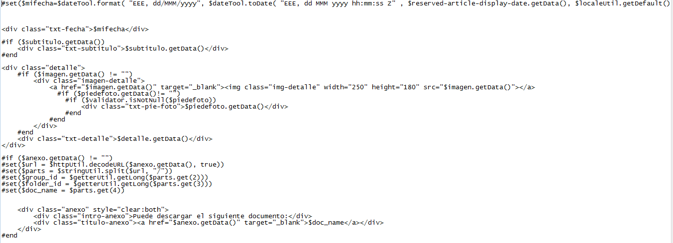

Archivo enlaces.vm
Archivo publicaciones.vm
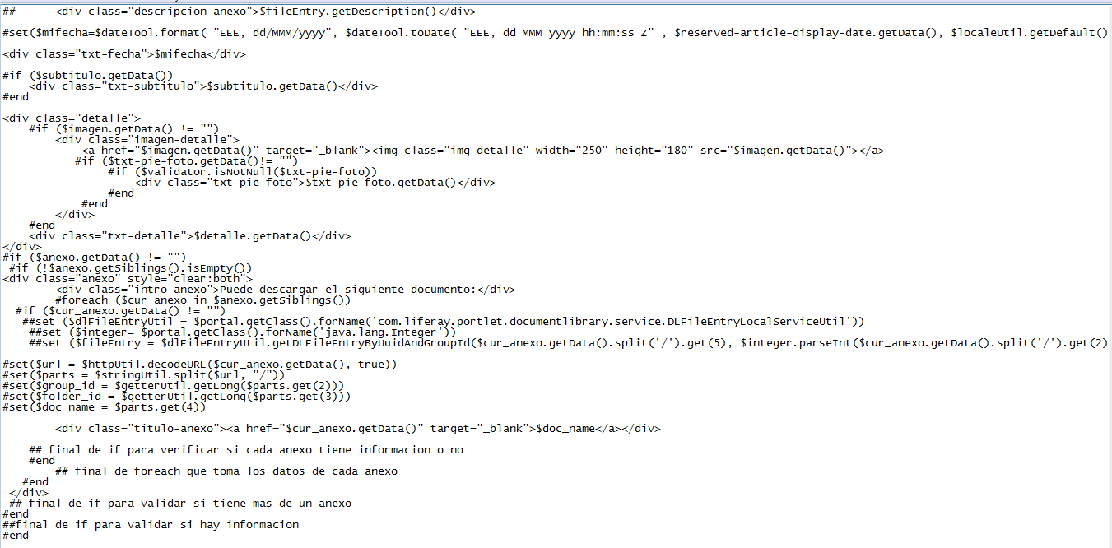

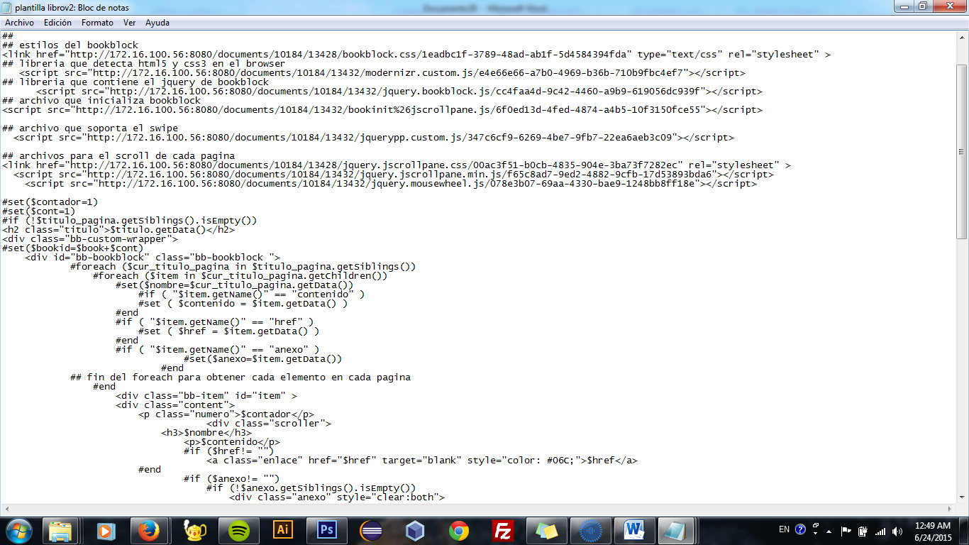
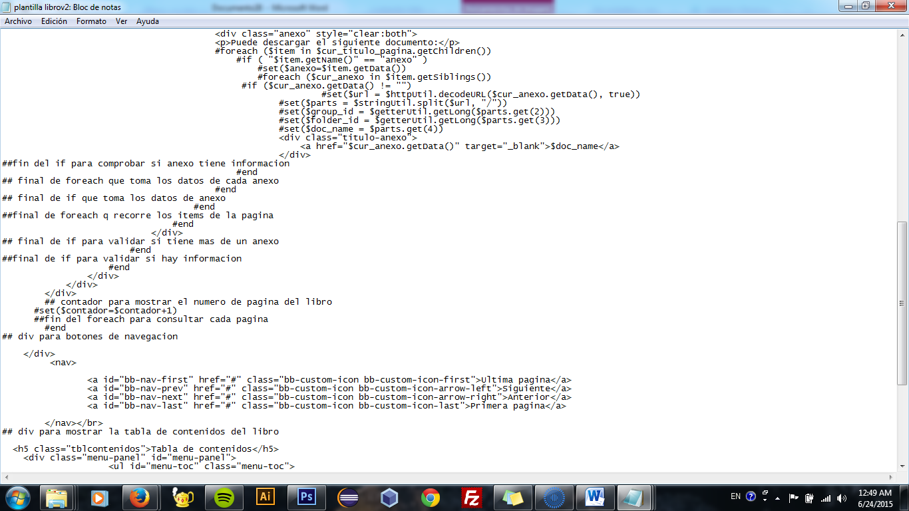
Archivo libros.vm
Archivo panel inicio.vm
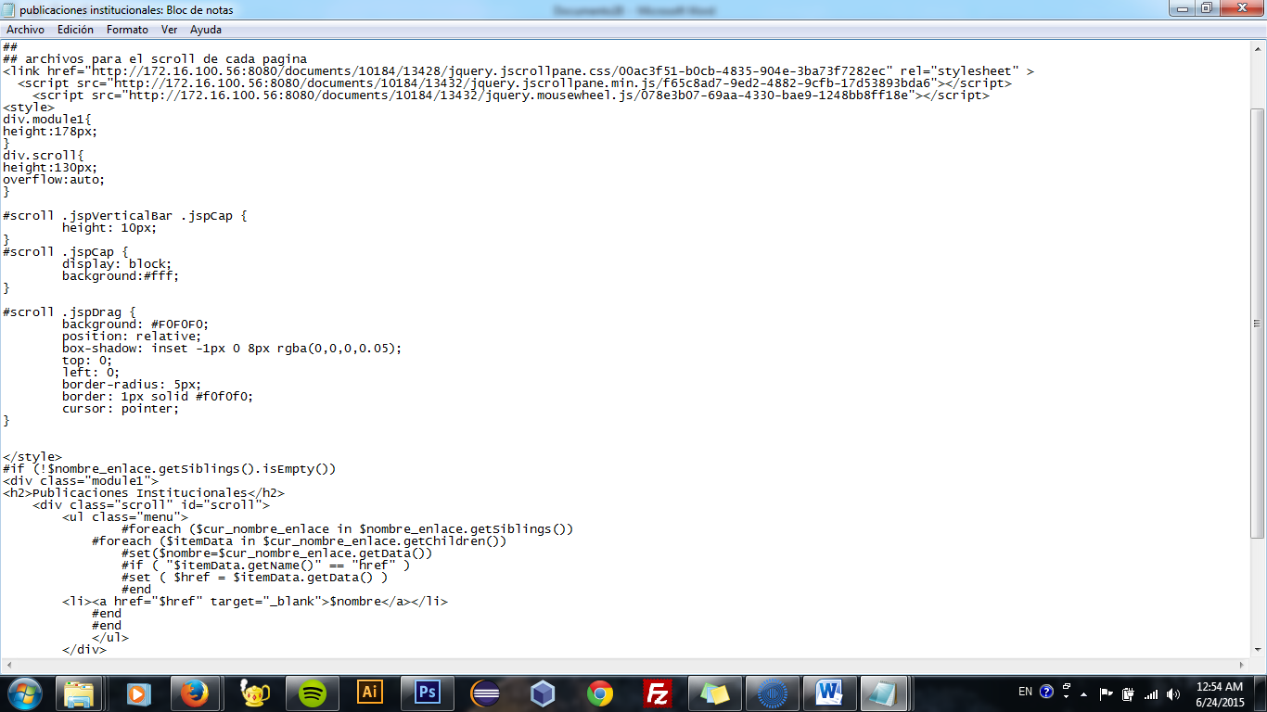
  - Banner noticias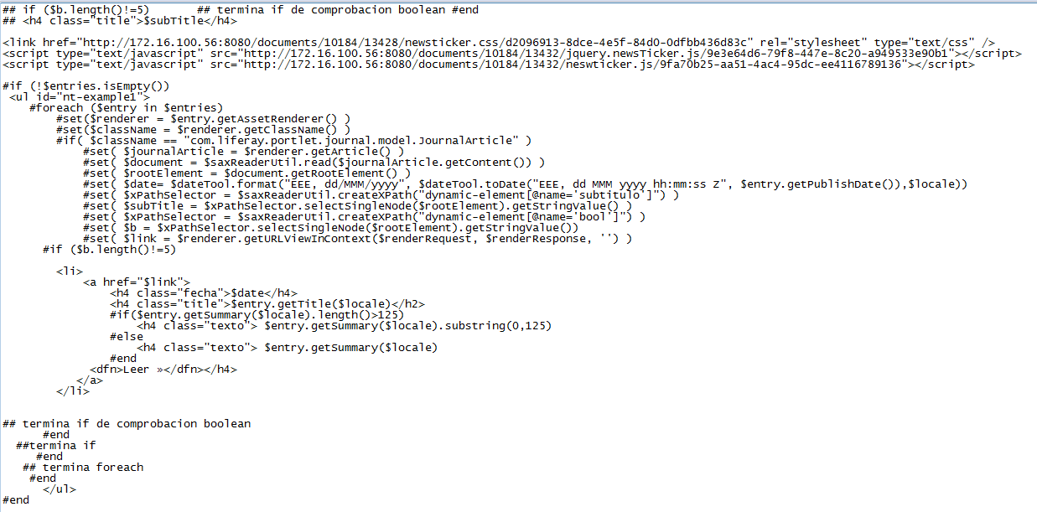
  - Estante libros
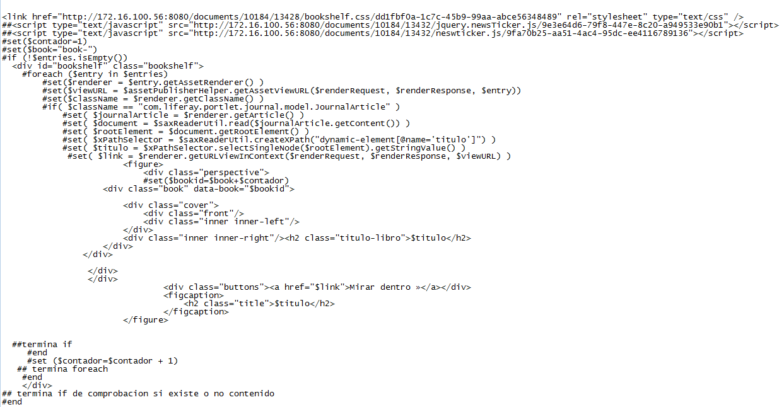

Estructuras de contenido
Archivo bannermultifuncion.xml
Archivo enlaces.xml
Archivo libro.xml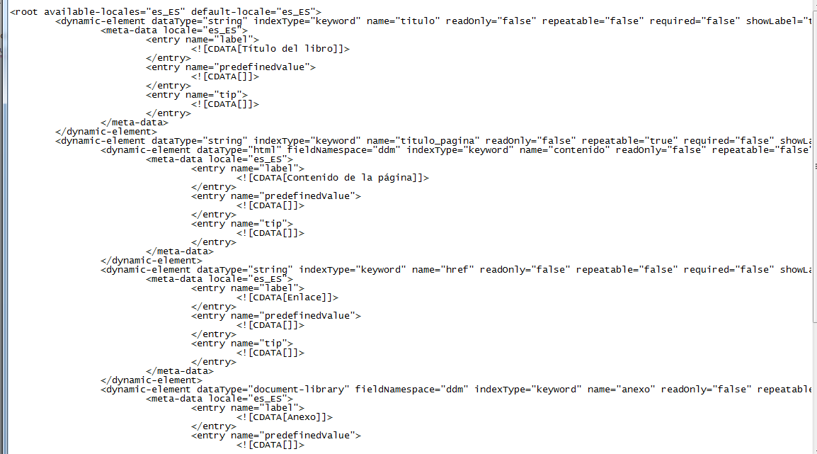
Archivo noticias.xml
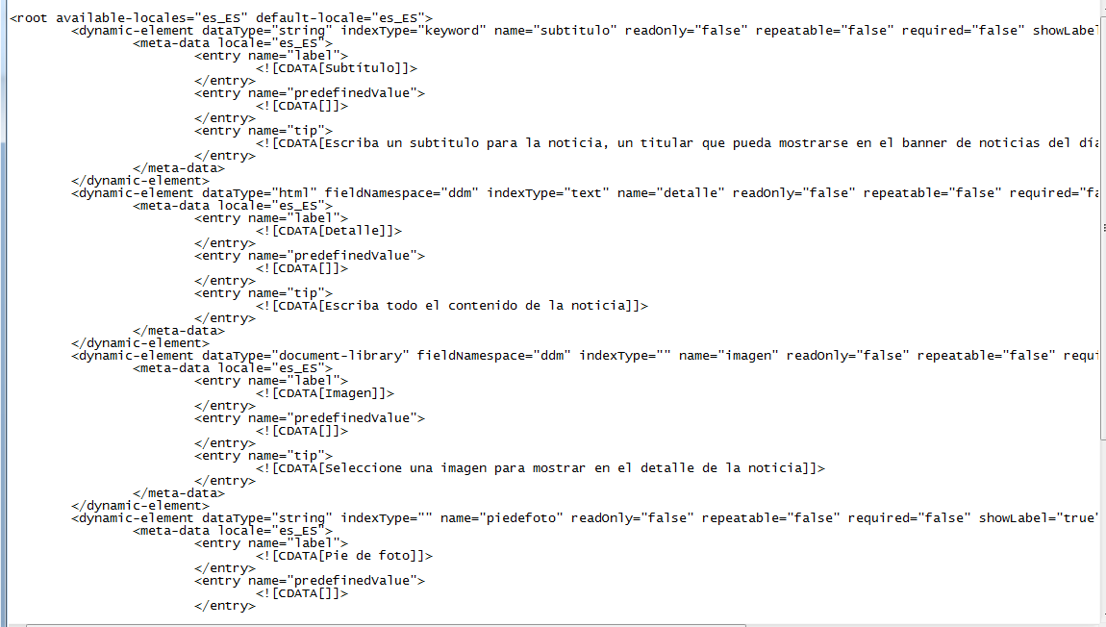
Archivo publicaciones.xml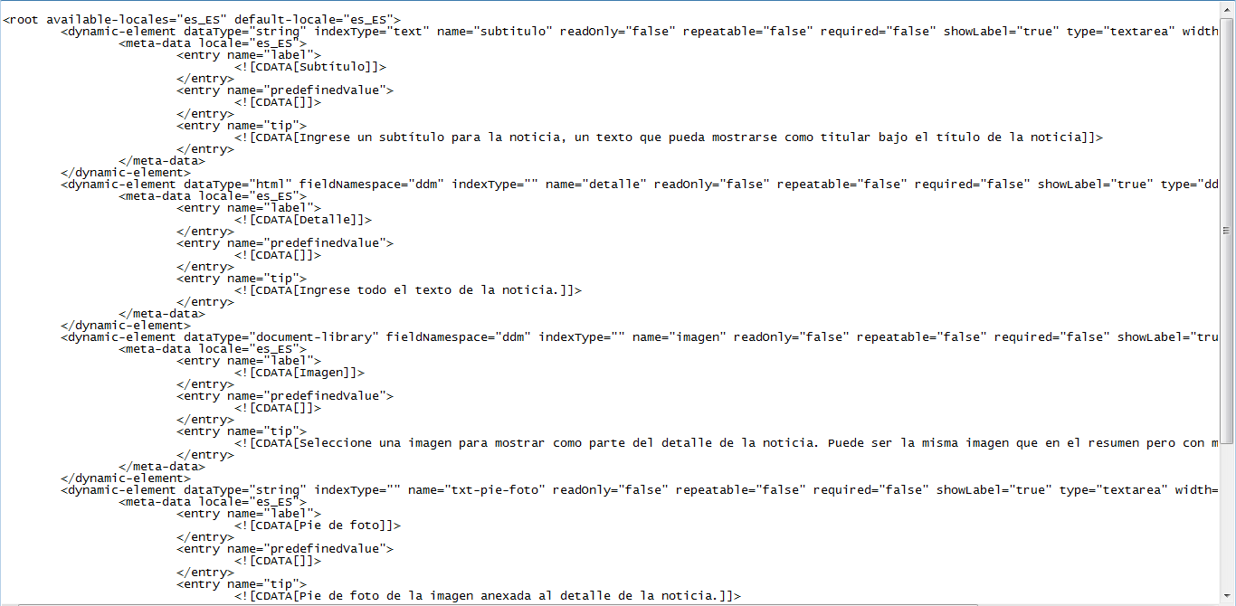
Archivo sliderimagenes.xml
Archivo panleinicio.xml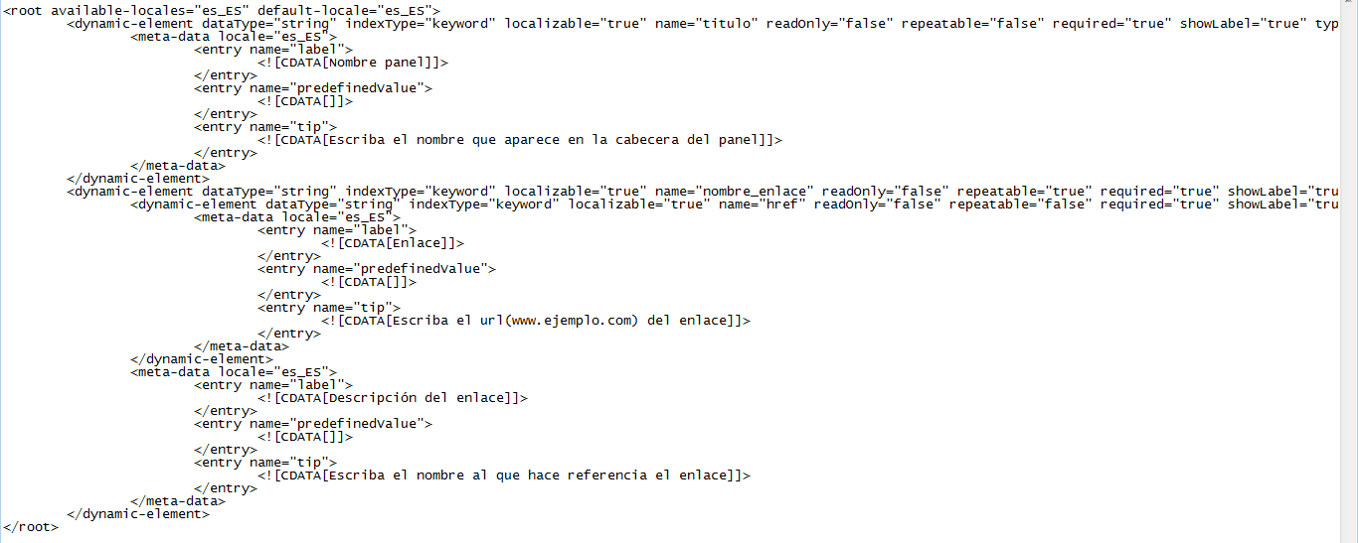
Hojas de estilo para portlets
  - Camino de migas
h2 {
font-size: 2em;
font-weight: bold;
color: #0077af;
margin: 0 0 20px 0;
border-bottom: 1px solid #CCC;
padding: 0 0 10px 0;
}

a {
color: #06C;
text-decoration: underline;
}

a:hover {
color: #CC9600;
}

/*********************************************************/

.columns-2 {
width:1030px;
margin-bottom: 20px;
}

.portlet-column-content-first{
width:320px;
}

.portlet-column-content-last{
margin-left:-30px;
width:705px;
}

.nav-menu ul li a {
display: block;
}

/*********************************************************/

div.eeq-content div.journal-content-article {
padding: 10px 30px;
background-color: #fff;
}

/*********************************************************/

.breadcrumb {
/* IE10 Consumer Preview */
background-image: -ms-linear-gradient(top, #FCFCFC 0%, #E6E6E6 100%);

/* Mozilla Firefox */
background-image: -moz-linear-gradient(top, #FCFCFC 0%, #E6E6E6 100%);

/* Webkit (Safari/Chrome 10) */
background-image: -webkit-gradient(linear, left top, left bottom, color-stop(0, #FCFCFC), color-stop(1, #E6E6E6));

/* Webkit (Chrome 11+) */
background-image: -webkit-linear-gradient(top, #FCFCFC 0%, #E6E6E6 100%);

/* W3C Markup, IE10 Release Preview */
background-image: linear-gradient(to bottom, #FCFCFC 0%, #E6E6E6 100%);

}

.portlet-breadcrumb ul li.section a {
font-weight: bold;
color: #666;
}
.portlet-breadcrumb a:hover {
color: #666;
}
  - Navegación por categorías
#p_p_id_122_INSTANCE_1PnGtUP7WYBp_ ul.aui-tree-hidden {
display: list-item;
}

#p_p_id_122_INSTANCE_1PnGtUP7WYBp_ .lfr-asset-category-list li {
float: left;
padding: 10px 0;
}

#p_p_id_122_INSTANCE_1PnGtUP7WYBp_ .lfr-asset-category-list span.tree-label {
background: url(/EEQtema-theme/images/common/tag.png) no-repeat 0 10%;
padding-left: 19px;
}

#p_p_id_122_INSTANCE_1PnGtUP7WYBp_ div.lfr-panel-container {
border: 0;
}

#p_p_id_122_INSTANCE_1PnGtUP7WYBp_ div.accordion-heading {
background: #eee;
-moz-box-shadow: 10px 10px 5px #888;
-webkit-box-shadow: 2px 2px 1px #ccc;
box-shadow: 2px 2px 1px #ccc;
padding-left: 5px;

}

#p_p_id_122_INSTANCE_1PnGtUP7WYBp_ a {
color: #06C;
text-decoration: underline;
}

#p_p_id_122_INSTANCE_1PnGtUP7WYBp_ a:hover{
color: #CC9600;
}

#p_p_id_122_INSTANCE_1PnGtUP7WYBp_ .accordion-toggle{
background:none;
cursor:default;
}
#p_p_id_122_INSTANCE_1PnGtUP7WYBp_ .lfr-asset-category-list-container {

cursor:default;
}

#p_p_id_122_INSTANCE_1PnGtUP7WYBp_ .accordion-group {
background:#ffffff;
}

#p_p_id_122_INSTANCE_1PnGtUP7WYBp_ {
margin-top:7px;
}
  - Publicador de contenidos
#p_p_id_101_INSTANCE_4EMrER4Zu93w_{
background-color:#fff;
padding:20px
}
#p_p_id_101_INSTANCE_4EMrER4Zu93w_ h3
{
text-shadow:none;
border-bottom:1px solid #DDD;
margin-top: 30px;
margin-left:10px;
margin-bottom:.7em;
margin-right:8px;
padding-bottom:1px;
font-family:arial;
font-weight:bold;
margin-top:0;
}
#p_p_id_101_INSTANCE_4EMrER4Zu93w_ h3 a
{
font-size: 70%;
color: #1167AE;
}

#p_p_id_101_INSTANCE_4EMrER4Zu93w_ h3 span
{
font-size: 90%;
color: #1167AE;

}
#p_p_id_101_INSTANCE_4EMrER4Zu93w_ div.asset-content
{
margin:0 10px
}

#p_p_id_101_INSTANCE_4EMrER4Zu93w_ div.asset-more
{
margin: 10px 0 15px;
}

#p_p_id_101_INSTANCE_4EMrER4Zu93w_ div.asset-more a{
color: #06C;
}

#p_p_id_101_INSTANCE_4EMrER4Zu93w_ div.asset-more a:hover {
color: #CC9600;
text-decoration: underline;
}

#p_p_id_101_INSTANCE_4EMrER4Zu93w_ .asset-small-image
{
float:left;
padding:0 10px 10px 0;
width:130px;
height:130px
}
#p_p_id_101_INSTANCE_4EMrER4Zu93w_ .asset-small-image img
{

max- width:100%;

}
#p_p_id_101_INSTANCE_4EMrER4Zu93w_ span.opens-new-window-accessible
{
display:none
}
#p_p_id_101_INSTANCE_4EMrER4Zu93w_ div.subscribe
{
margin-left:9px
}
#p_p_id_101_INSTANCE_4EMrER4Zu93w_ div.taglib-header span.header-back-to a
{
padding: 0.5em .2em;
}

#p_p_id_101_INSTANCE_4EMrER4Zu93w_ div.taglib-header
{
border:0;
}
#p_p_id_101_INSTANCE_4EMrER4Zu93w_ div.asset-actions
{
margin-bottom:7px
}
#p_p_id_101_INSTANCE_4EMrER4Zu93w_ div.asset-summary
{
text-align:justify
}
#p_p_id_101_INSTANCE_4EMrER4Zu93w_ div.txt-detalle
{
text-align:justify;
}
#p_p_id_101_INSTANCE_4EMrER4Zu93w_ div.txt-subtitulo
{
font-size: medium;
color: #665;
margin-bottom: 14px;
text-shadow: .02em .02em #ccc;
max-width: 460px;
}

#p_p_id_101_INSTANCE_4EMrER4Zu93w_ .portlet-asset-publisher img.img-detalle
{
width: 250px;
height: 180px;
margin:0 10px 5px 0;
border:0;
float:left
}
#p_p_id_101_INSTANCE_4EMrER4Zu93w_ div.taglib-page-iterator
{
margin:10px 10px 15px;
background-color:#eee
}
#p_p_id_101_INSTANCE_4EMrER4Zu93w_ div.search-results
{
float:none;
margin:10px
}
#p_p_id_101_INSTANCE_4EMrER4Zu93w_ div.search-pages
{
float:none;
margin:0 0 20px 10px
}
#p_p_id_101_INSTANCE_4EMrER4Zu93w_ div.delta-selector
{
display:none
}
#p_p_id_101_INSTANCE_4EMrER4Zu93w_ div.page-links
{
margin:5px 10px
}
#p_p_id_101_INSTANCE_4EMrER4Zu93w_ div.page-selector
{
margin:0 10px 10px 0;
padding:0 10px 0 0
}
#p_p_id_101_INSTANCE_4EMrER4Zu93w_ div.asset-actions a.taglib-icon
{
padding:0;
margin:10px;
font-weight:normal
}
#p_p_id_101_INSTANCE_4EMrER4Zu93w_ div.asset-metadata
{
margin: 0 10px;
background: #eee;
-moz-box-shadow: 10px 10px 5px #888;
-webkit-box-shadow: 2px 2px 1px #ccc;
box-shadow: 2px 2px 1px #ccc;
padding-left: 5px;
}

#p_p_id_101_INSTANCE_4EMrER4Zu93w_ div.asset-metadata span.metadata-entry
{
background:#eee;
padding:7px 0 7px 6px
}
#p_p_id_101_INSTANCE_4EMrER4Zu93w_ .taglib-asset-tags-summary .tag {
color: #06C;
}

#p_p_id_101_INSTANCE_4EMrER4Zu93w_ .taglib-asset-tags-summary .tag:hover
{
color: #CC9600;
text-decoration:underline
}

#p_p_id_101_INSTANCE_4EMrER4Zu93w_ div.anexo
{
margin:20px 0 10px 0;
padding:6px 10px;
background-color:#eee;
-moz-box-shadow:10px 10px 5px #888;
-webkit-box-shadow:2px 2px 1px #ccc;
box-shadow:2px 2px 1px #ccc
}
#p_p_id_101_INSTANCE_4EMrER4Zu93w_ div.anexo div.intro-anexo
{
margin-bottom:5px
}
#p_p_id_101_INSTANCE_4EMrER4Zu93w_ div.anexo div.titulo-anexo
{
margin-bottom:5px;
}
#p_p_id_101_INSTANCE_4EMrER4Zu93w_ div.anexo div.titulo-anexo a
{
margin-bottom:5px;
background: url(/EEQtema-theme/images/download-icon.png) no-repeat 0 10%;
background-size:15px 15px;
padding:0px 0px 0px 20px
}
#p_p_id_101_INSTANCE_4EMrER4Zu93w_ div.descripcion-anexo
{
color:#999
}

#p_p_id_101_INSTANCE_4EMrER4Zu93w_ span.taglib-asset-categories-summary a.asset-category {
background: url(/EEQtema-theme/images/common/tag.png) no-repeat 0 10%;
color: #06C;
padding-left: 19px;
margin: 0 3px 3px 10px;
margin-right: 3px;
}
#p_p_id_101_INSTANCE_4EMrER4Zu93w_ span.taglib-asset-categories-summary a.asset-category:hover {
color: #CC9600;
text-decoration: underline;
}

#p_p_id_101_INSTANCE_4EMrER4Zu93w_ div.final-separator {
border: 2px solid #eee;
margin: 30px -30px 20px;
}

#p_p_id_101_INSTANCE_4EMrER4Zu93w_ div.asset-abstract {
margin: 20px 0 50px;
}

#p_p_id_101_INSTANCE_4EMrER4Zu93w_ div.txt-fecha
{
float: right;
background: url(/EEQtema-theme/images/common/date.png) no-repeat 10% 2%;
padding-left: 35px;
margin: 3px 0 15px 0;
}

#p_p_id_101_INSTANCE_4EMrER4Zu93w_ div.imagen-detalle {
max-width: 250px;
float: left;
margin: 0 20px 15px 0;
}

#p_p_id_101_INSTANCE_4EMrER4Zu93w_ div.detalle{
clear: both;
}

#p_p_id_101_INSTANCE_4EMrER4Zu93w_ div.txt-pie-foto {
text-align: justify;
font-style: italic;
background-color: #eee;
padding: 6px;
border: 1px solid #c8c9ca;
}
#p_p_id_101_INSTANCE_4EMrER4Zu93w_ .portlet-borderless.portlet-asset-publisher div.taglib-social-bookmarks {
background-color: #eee;
-moz-box-shadow: 10px 10px 5px #888;
-webkit-box-shadow: 2px 2px 1px #ccc;
box-shadow: 2px 2px 1px #ccc;
padding-left: 5px;
}

#p_p_id_101_INSTANCE_4EMrER4Zu93w_ .portlet-borderless.portlet-asset-publisher div.taglib-social-bookmarks ul {
padding: 10px 10px 8px;
}

#p_p_id_101_INSTANCE_4EMrER4Zu93w_ .clearfix {
padding:10px 10px;

}

#p_p_id_101_INSTANCE_4EMrER4Zu93w_ .taglib-page-iterator .lfr-pagination-config .lfr-pagination-delta-selector, .taglib-page-iterator .lfr-pagination-config .lfr-pagination-page-selector {

padding:0 0 0 6px;
}
  - Publicador de contenidos noticias

#p_p_id_101_INSTANCE_llC1biaB0slf_ h3
{
border-bottom:1px solid #DDD;
margin-top: 30px;
margin-left:10px;
margin-bottom:.7em;
margin-right:8px;
padding-bottom:1px;
font-family:arial;
font-weight:bold;
margin-top:0;
}
#p_p_id_101_INSTANCE_llC1biaB0slf_ h3 a
{
color: #1167AE;
font-size: 70%;
}
#p_p_id_101_INSTANCE_llC1biaB0slf_ h3 span
{
color: #1167AE;
font-size: 90%;
}
#p_p_id_101_INSTANCE_llC1biaB0slf_ div.asset-content
{
margin:0 10px
}

#p_p_id_101_INSTANCE_llC1biaB0slf_ div.asset-more
{
margin: 10px 0 15px;
}

#p_p_id_101_INSTANCE_llC1biaB0slf_ div.asset-more a{
color: #06C;
}

#p_p_id_101_INSTANCE_llC1biaB0slf_ div.asset-more a:hover {
color: #CC9600;
text-decoration: underline;
}

#p_p_id_101_INSTANCE_llC1biaB0slf_ .asset-small-image
{
float:left;
padding:0 10px 10px 0;
width:130px;
height:130px
}

#p_p_id_101_INSTANCE_llC1biaB0slf_ .asset-small-image img
{
max-width:100%;

}
#p_p_id_101_INSTANCE_llC1biaB0slf_ span.opens-new-window-accessible
{
display:none
}
#p_p_id_101_INSTANCE_llC1biaB0slf_ div.subscribe
{
margin-left:9px
}
#p_p_id_101_INSTANCE_llC1biaB0slf_ div.taglib-header span.header-back-to a
{
padding: 0.5em .2em;
}

#p_p_id_101_INSTANCE_llC1biaB0slf_ div.taglib-header
{
border:0;
}
#p_p_id_101_INSTANCE_llC1biaB0slf_ div.asset-actions
{
margin-bottom:7px
}
#p_p_id_101_INSTANCE_llC1biaB0slf_ div.asset-summary
{
text-align:justify
}
#p_p_id_101_INSTANCE_llC1biaB0slf_ div.txt-detalle
{
text-align:justify;

}
#p_p_id_101_INSTANCE_llC1biaB0slf_ div.txt-detalle p
{
line-height:25px;

}
#p_p_id_101_INSTANCE_llC1biaB0slf_ div.txt-subtitulo
{
font-size: medium;
color: #929292;
margin-bottom: 14px;
text-shadow: .02em .02em #ccc;
max-width: 460px;
}

#p_p_id_101_INSTANCE_llC1biaB0slf_ .portlet-asset-publisher img.img-detalle
{
width: 250px;
height: 180px;
margin:0 10px 5px 0;
border:0;
float:left
}
#p_p_id_101_INSTANCE_llC1biaB0slf_ div.taglib-page-iterator
{
margin:10px 10px 15px;
background-color:#eee
}
#p_p_id_101_INSTANCE_llC1biaB0slf_ div.taglib-page-iterator div.search-results
{
float:none;
margin:10px
}
#p_p_id_101_INSTANCE_llC1biaB0slf_ div.taglib-page-iterator div.search-pages
{
float:none;
margin:0 0 20px 10px
}
#p_p_id_101_INSTANCE_llC1biaB0slf_ div.taglib-page-iterator div.delta-selector
{
display:none
}
#p_p_id_101_INSTANCE_llC1biaB0slf_ div.taglib-page-iterator div.page-links
{
margin:5px 10px
}
#p_p_id_101_INSTANCE_llC1biaB0slf_ div.taglib-page-iterator div.page-selector
{
margin:0 10px 10px 0;
padding:0 10px 0 0
}
#p_p_id_101_INSTANCE_llC1biaB0slf_ div.asset-actions a.taglib-icon
{
padding:0;
margin:10px;
font-weight:normal
}
#p_p_id_101_INSTANCE_llC1biaB0slf_ div.asset-metadata
{
margin: 0 10px;
background: #eee;
-moz-box-shadow: 10px 10px 5px #888;
-webkit-box-shadow: 2px 2px 1px #ccc;
box-shadow: 2px 2px 1px #ccc;
padding-left: 8px;
padding-top:3px;
}

#p_p_id_101_INSTANCE_llC1biaB0slf_ .taglib-asset-tags-summary .tag {
color: #06C;
}

#p_p_id_101_INSTANCE_llC1biaB0slf_ .taglib-asset-tags-summary .tag:hover
{
color: #CC9600;
text-decoration:underline
}

#p_p_id_101_INSTANCE_llC1biaB0slf_ div.anexo
{
margin:20px 0 10px 0;
padding:6px 10px;
background-color:#eee;
-moz-box-shadow:10px 10px 5px #888;
-webkit-box-shadow:2px 2px 1px #ccc;
box-shadow:2px 2px 1px #ccc
}
#p_p_id_101_INSTANCE_llC1biaB0slf_ div.anexo div.intro-anexo
{
margin-bottom:5px
}
#p_p_id_101_INSTANCE_llC1biaB0slf_ div.anexo div.titulo-anexo
{
margin-bottom:5px;
}

#p_p_id_101_INSTANCE_llC1biaB0slf_ div.anexo div.titulo-anexo a
{
margin-bottom:5px;
background: url(/NuevoEEQtema-theme/images/download-icon.png) no-repeat 0 10%;
background-size:15px 15px;
padding:0px 0px 0px 20px;
}
#p_p_id_101_INSTANCE_llC1biaB0slf_ div.anexo div.descripcion-anexo
{
color:#999
}

#p_p_id_101_INSTANCE_llC1biaB0slf_ .portlet-asset-publisher .metadata-author {
background-image:url(/NuevoEEQtema-theme/images/portlet/edit_guest.png) 0px 0 no-repeat;
float:left;
font-weight:bold;
margin-right:10px;
padding-left:25px;
}

#p_p_id_101_INSTANCE_llC1biaB0slf_ div.final-separator {
border: 2px solid #eee;
margin: 30px -30px 20px;
}

#p_p_id_101_INSTANCE_llC1biaB0slf_ div.asset-abstract {
margin: 20px 0 50px;
}

#p_p_id_101_INSTANCE_llC1biaB0slf_ div.txt-fecha
{
float: right;
background: url(Nuevo/EEQtema-theme/images/common/date.png) no-repeat 10% 2%;
padding-left: 35px;
margin: 3px 0 15px 0;
}

#p_p_id_101_INSTANCE_llC1biaB0slf_ h1.header-title span {
padding-right: 10px;
}

#p_p_id_101_INSTANCE_llC1biaB0slf_ div.imagen-detalle {
max-width: 250px;
float: left;
margin: 0 20px 15px 0;
}

#p_p_id_101_INSTANCE_llC1biaB0slf_ div.detalle{
clear: both;
}

#p_p_id_101_INSTANCE_llC1biaB0slf_ div.txt-pie-foto {
text-align: justify;
font-style: italic;
background-color: rgba(153, 204, 255, 0.3);
padding: 6px;
border: 1px solid #c8c9ca;
font-size:10px;
}
#p_p_id_101_INSTANCE_llC1biaB0slf_ .portlet-borderless.portlet-asset-publisher div.taglib-social-bookmarks {
background-color: #eee;
-moz-box-shadow: 10px 10px 5px #888;
-webkit-box-shadow: 2px 2px 1px #ccc;
box-shadow: 2px 2px 1px #ccc;
padding-left: 5px;
}

#p_p_id_101_INSTANCE_llC1biaB0slf_ .portlet-borderless.portlet-asset-publisher div.taglib-social-bookmarks ul {
padding: 10px 10px 8px;
}

#p_p_id_101_INSTANCE_llC1biaB0slf_ h3 {
text-shadow: none;
white-space:normal;
}

#p_p_id_101_INSTANCE_llC1biaB0slf_ {
margin-top:-32px;
padding:30px 20px 20px 20px;
background:#ffffff;

}

